DAY 2 – XRAY SETUP & CONFIGURATION
Xray Setup: Xray Cloud overview, project-level configuration, global vs project settings
Xray Issue Types: Test structure, Test Execution structure, Test Plan vs Test Set, Precondition reuse
UI & Panels: Xray panels, coverage view, execution view, defect visibility, navigation shortcuts
Roles & Permissions: QA access, developer role, admin controls, common permission issues

Xray Setup: Xray Cloud overview, project-level configuration, global vs project settings ::
Xray Cloud Overview :
Xray Cloud is the cloud-based deployment of Xray that runs on Atlassian Cloud. It is widely used by organizations that prefer minimal infrastructure management and faster scalability.
Key Characteristics of Xray Cloud:
- Hosted and maintained by Atlassian
- Automatic updates and upgrades
- High availability and reliability
- Easy access from anywhere
Xray Cloud integrates with Jira Cloud projects and supports Agile workflows such as Scrum and Kanban. Users can start using Xray almost immediately after installation without worrying about server maintenance.

Project-Level Configuration in Xray :
Project-level configuration defines how Xray behaves within a specific Jira project. This allows different projects to have customized testing processes based on their needs.
At the project level, administrators can configure:
- Enabled Xray issue types
- Workflow associations
- Field configurations
- Notification rules
Project-level settings ensure flexibility and allow teams to adapt Xray to various project methodologies.
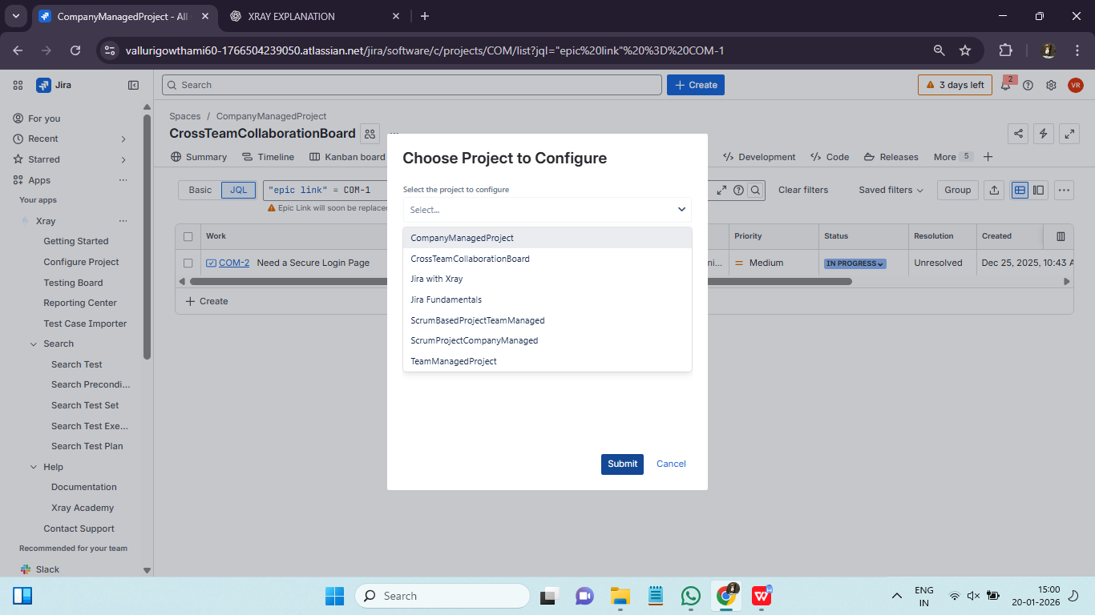

Global vs Project Settings :
Understanding the difference between global and project settings is crucial for effective Xray administration.
Global Settings:
- Apply to all projects
- Managed by Jira or Xray administrators
- Include licensing, automation settings, and global behaviours
Project Settings:
- Apply only to a specific project
- Managed by project admins
- Include issue type configurations and permissions
A clear separation of responsibilities helps maintain governance while allowing project-level autonomy.

Xray Issue Types: Test structure, Test Execution structure, Test Plan vs Test Set, Precondition reuse ::
Test :
Represents a single test case. It includes test steps, expected results, and conditions required for execution. It is a jira issue type and contains summary and description. Types of tests are :
- Manual test : step by step , executed by tester
- Automated test : Linked to automation code , results imported
- BDD test : Gherkin syntax, Given-When-Then

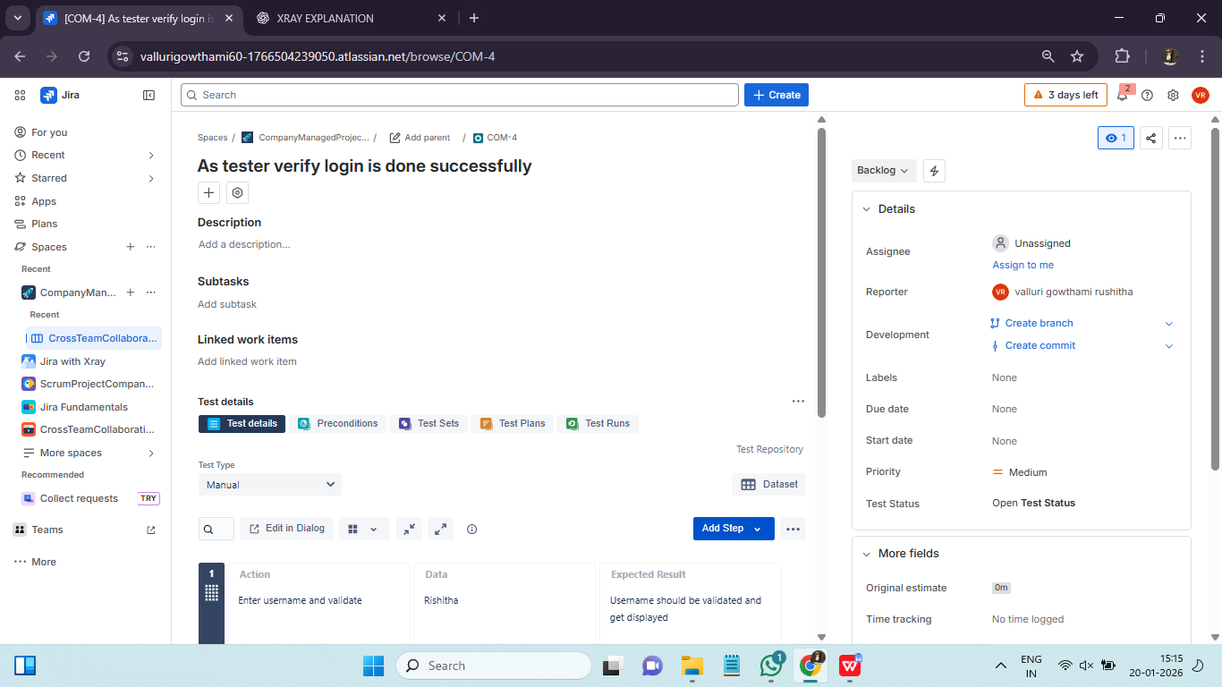

Test Execution :
Represents the execution of one or more tests at a specific point in time. It records test results such as Pass, Fail, or Blocked. Each test inside a execution can be :
- Pass : Test succeeded
- Fail : Test failed
- Blocked : Dependency issue
- To Do : Not executed
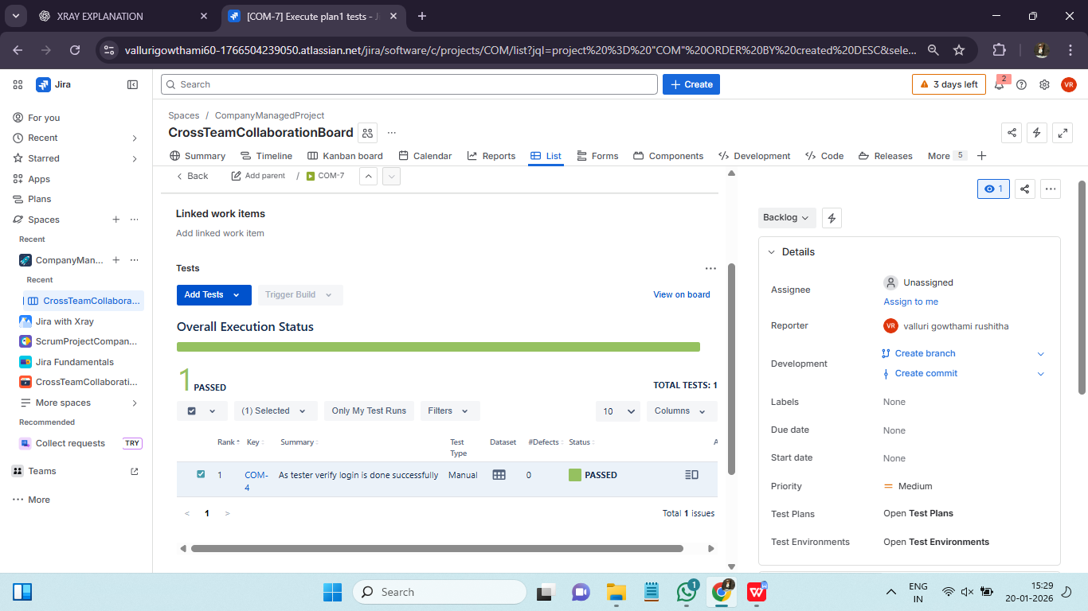

Test Plan :
Used to organize tests and executions for a specific release or milestone. It can be used in sprint planning, release based regression, compliance tracking.
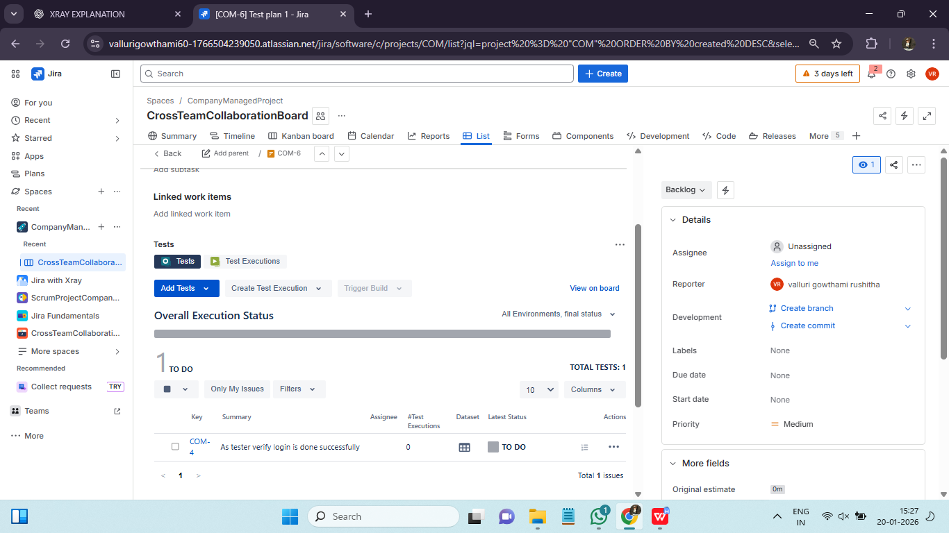
Test Set :
A logical grouping of tests, such as smoke tests or regression suites.

Test Plan :
- Strategy
- Long term
- Dynamic
Test Set :
- Grouping
- Reusable
- Static

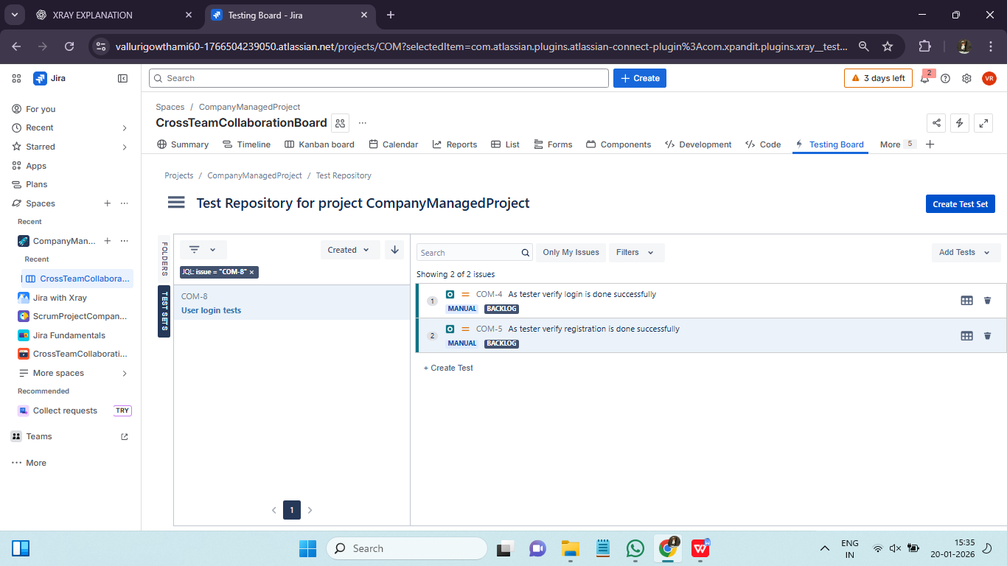

Precondition :
Defines common setup conditions required before executing tests. Preconditions can be reused across multiple tests. It avoids duplication, maintains consistency, faster test design.

UI & Panels: Xray panels, coverage view, execution view, defect visibility, navigation shortcuts ::
Xray adds several user interface components to Jira that enhance test visibility and navigation.
Xray Panels :
- Test Details Panel
- Test Coverage Panel
- Test Execution Panel
- Defects Panel
These panels provide quick access to test-related information without leaving the Jira issue view.
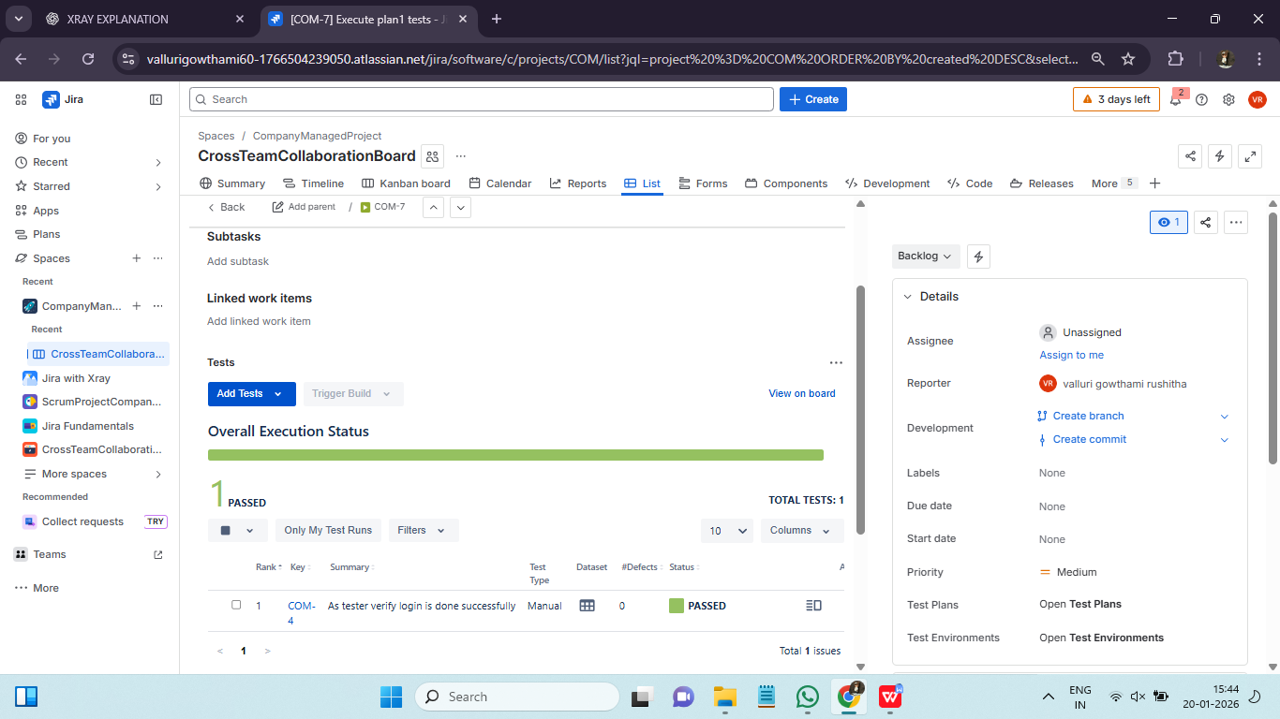
Coverage View and Execution View :
Coverage View:
Displays which tests are linked to requirements and their current status. This view helps teams identify coverage gaps.
Execution View:
Shows the execution status of tests, including pass and fail statistics. It provides insights into testing progress.
Both views support decision-making during sprint reviews and release planning.
Defect Visibility and Traceability :
Xray improves defect management by linking failed tests directly to bugs. This linkage allows teams to:
- Track defects back to test cases
- Retest defects after fixes
- Maintain execution history
Defect traceability ensures accountability and faster resolution.
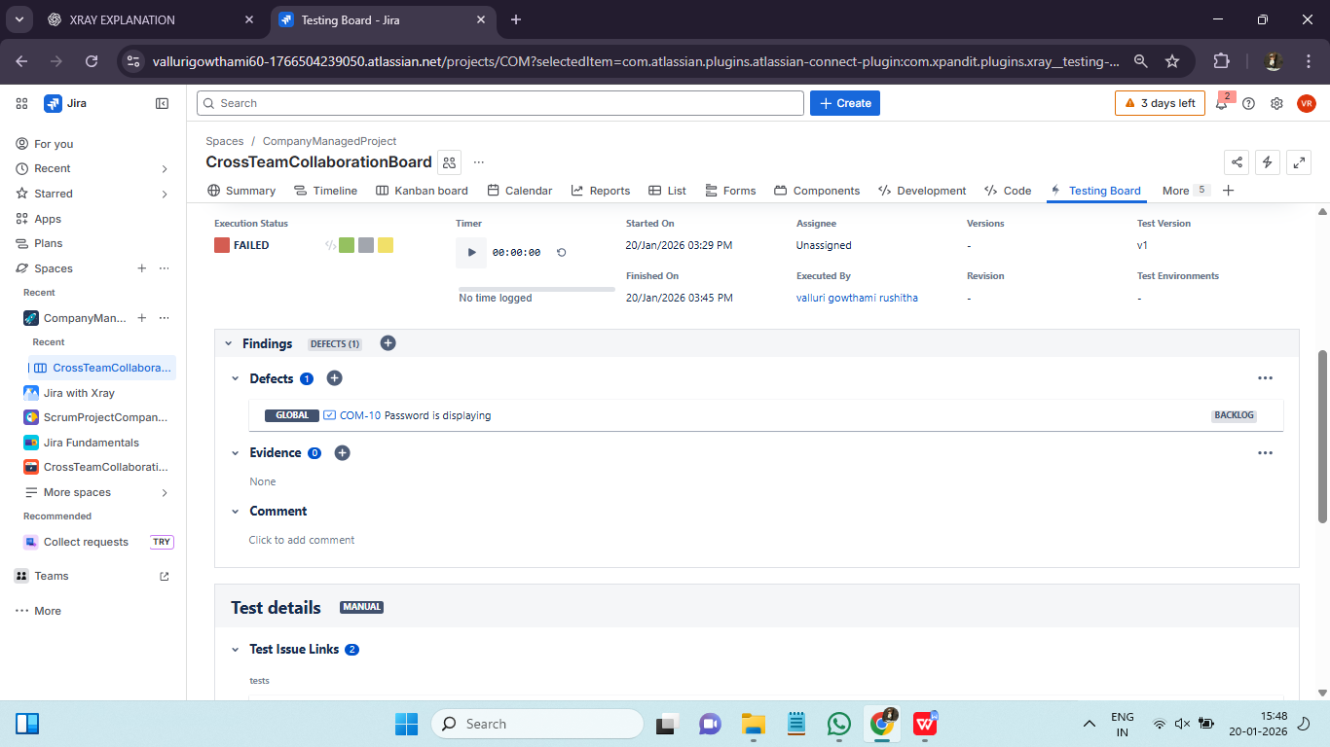
Navigation Shortcuts and Productivity Tips :
Xray provides navigation shortcuts that help users quickly move between tests, executions, and plans. Common tips include:
- Using filters to locate tests
- Saving frequently used JQL queries
- Customizing views for faster access
These practices improve productivity and reduce time spent searching for information.

Roles & Permissions: QA access, developer role, admin controls, common permission issues ::
Role-based access control is critical for maintaining data integrity and security.
Common Roles:
- QA Engineer
- Developer
- Project Manager
- Jira Administrator
Each role has specific permissions related to creating, editing, executing, and viewing tests.
Common Permission Issues
Common issues include:
- Inability to execute tests
- Missing fields during test creation
- Restricted access to reports

